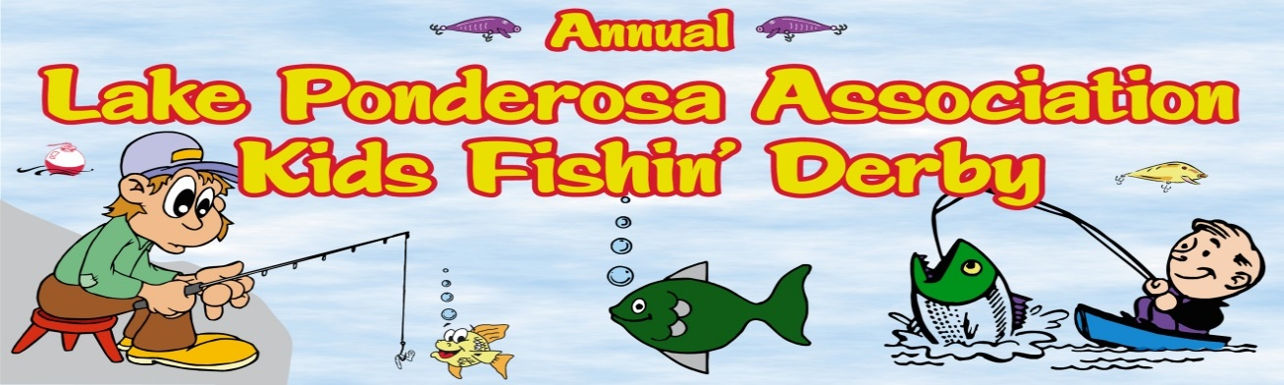 24th ANNUAL KID’S FISH’N DERBY
Saturday, June 18, 2022
Derby Fishing Time: 9:00 am to 11:00 am

Location: Association Boat Ramp
Weigh-In: 11:00 am until Noon
Lunch starts at 11:00 am

AWARDS AND PRIZES AFTER WEIGH-IN
The derby is open to kids up to 14 years old. At least one adult who is 21 years old and a lake property owner or guest must accompany the kids. Individual anglers can fish from shore or in a boat and there can be more than one angler per boat. Anglers will be fishing for two categories, Crappie/Bluegill and Catfish. Trophies will be awarded for 1st and 2nd place for the heaviest total weight of 5 fish of each of the two categories and for Small Fry (smallest fish of all species). Only Bluegill, Crappie, and Catfish can be caught. NO BASS OR WALLEYES.
We will also give away many great prizes, so everyone will be a winner.
Please do all you can to keep fish alive if you are not going to keep them. If you use a stringer, never hook through the gills, only the mouth.
To volunteer, contact Sunni Kegebein at (319) 427-1592 or by email at kegebeins55@gmail.com.
There will be no same day registration. All entries must be received no later June 8, 2022. Please complete and submit the following form. There is no cost to participle in the Fishin’ Derby however please consider making a free will donation to be put towards stocking fish in the lake.
------------------------------------------------------------------------------------------------------------------------------------------------------------------
PRE-REGISTRATION FORM
This information is needed so we know how many prizes to buy. To pre-register email form to kegebeins55@gmail.com, phone Sunni at (319) 427-1592 or drop off at the lake office. Free will donations can be mailed to LPA, PO Box 751, Montezuma, IA 50171 or brought to the boat ramp the day of the Derby.

Sponsor’s Name_____________________________________ Address _____________________________________
Phone _______________________________
Names and Ages of Kids
Name (First and Last) Age Name (First and Last) Age

________________________________ _________________________________

________________________________ __________________________________

